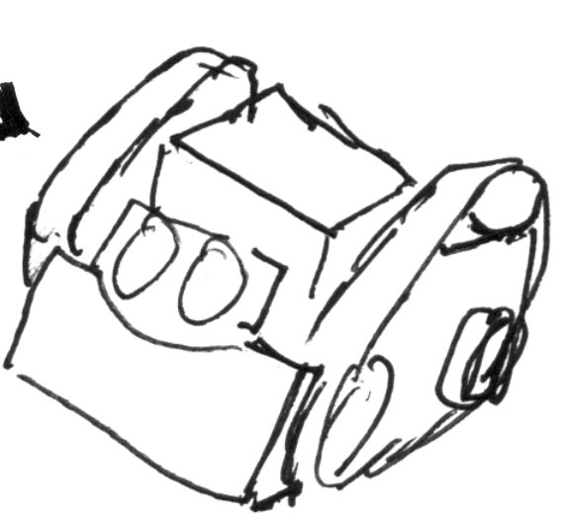

Sumo Robot League

Online Resources

## [3D Files of Robot Parts](https://drive.google.com/open?id=0B4flp9EZKozra2ZvdVFlTk5ON3c) http://bit.ly/2rQwSgI

## [GitHub, TextBook code](https://github.com/SumoRobotLeague/MRK-1) http://bit.ly/2tJedoe

## [GitHub, Other code](https://github.com/SumoRobotLeague/MRK-1_Misc) http://bit.ly/2slSLYu

## [Youtube Channel](https://www.youtube.com/channel/UC0WCv8s-wjs_T7GnELdtvow) <http://bit.ly/2rz3hZL>

Day 1 Building the bots, Rules

Day 2 Arduino IDE, What is a microprocesor, Blinky LED

Day 3 Data Types, Variables, Functions, Sensors

Day 4 Motors (provide the library), Controlling Motors based on sensor input (ultrasound = distance, line sensors = b/w, user button),

Start Sumo Competition programming (convert object avoidance)

Day 5 Finish competition code (there is functional code in Github), Hold a competition

Line sensor (make a running average to reduce noise)